**Mandatory training via Health Education Training Institute (HETI) Moodle** 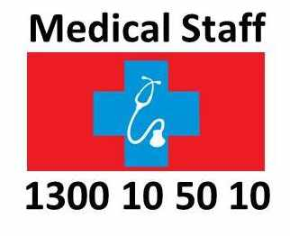

**Step 1:** Go to <http://nswhealth.moodle.com.au>

**Step 2:** Type an easy to remember username and password in the login section of the page.

If the username is already being used by another user an error message will appear saying “Invalid login,

Please try again”.

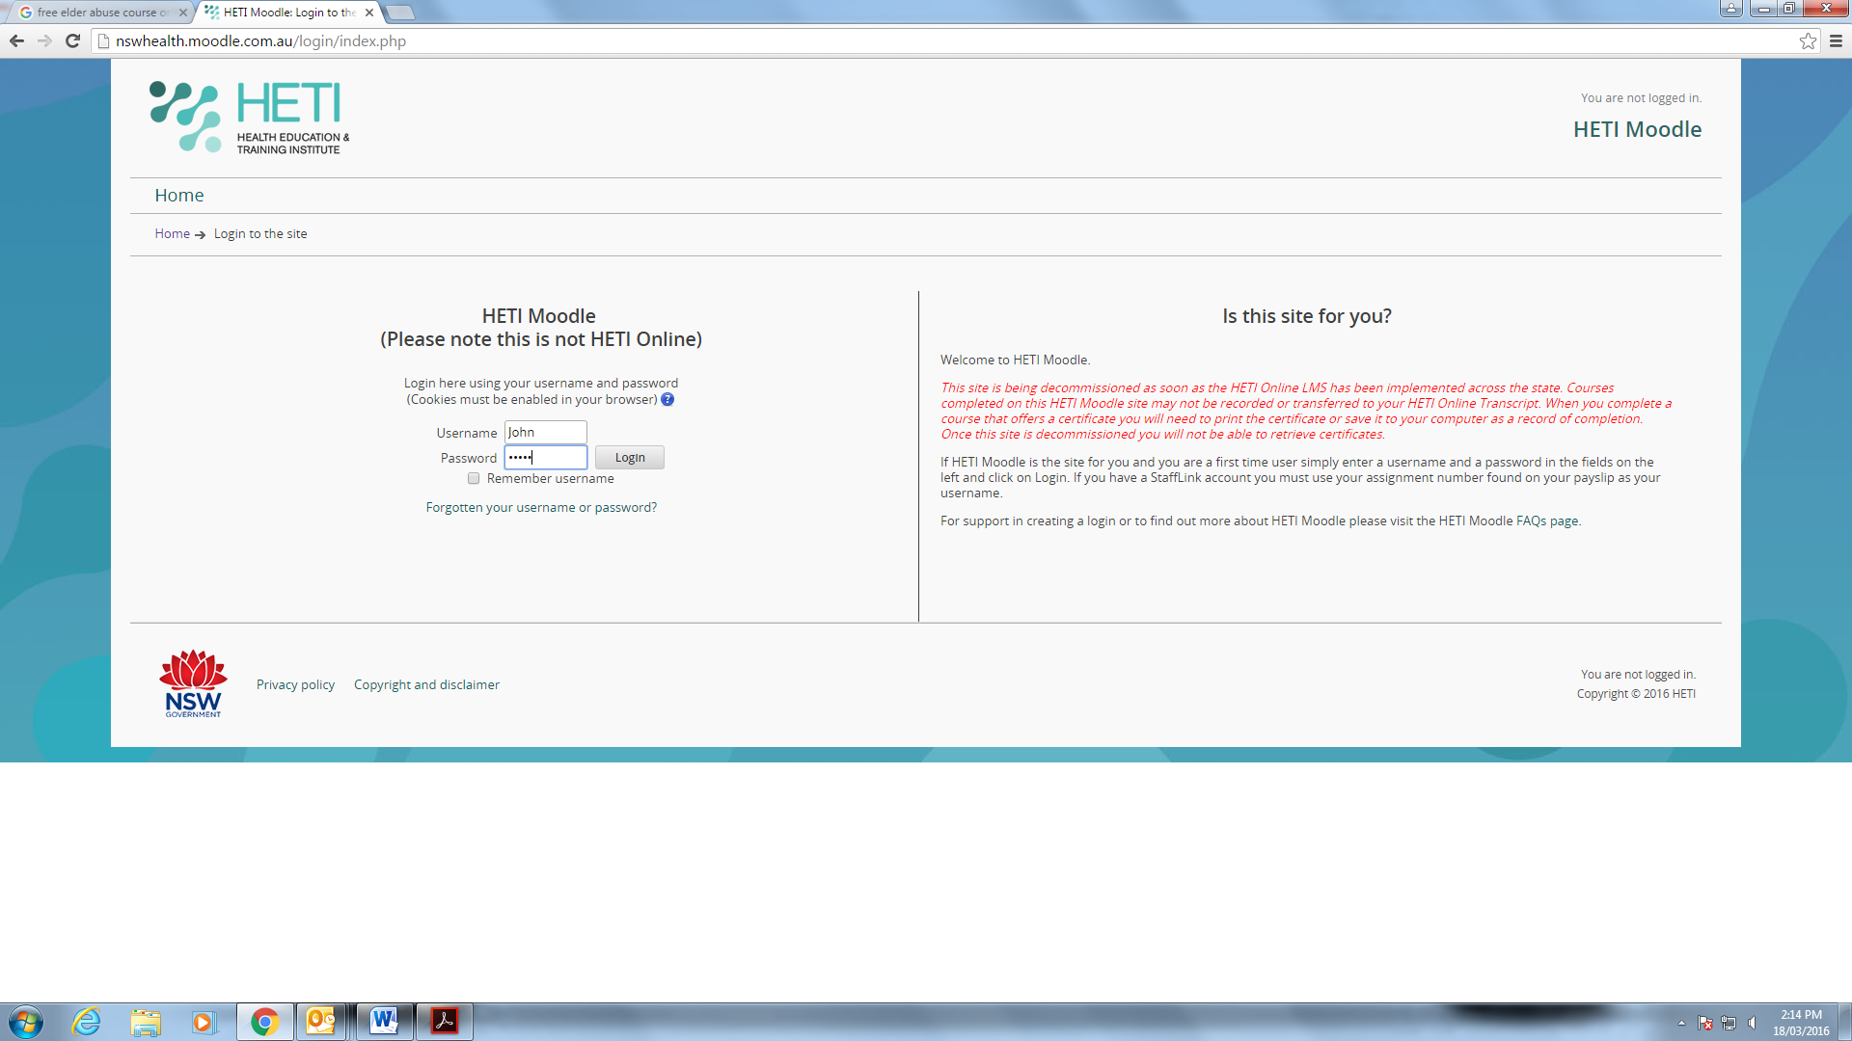

**Step 3: Complete the profile page **

**Facility:** Medical staff

**Payroll Number**: Fill in your public payroll number.

“***Please make up a random 8-digit number if you don’t have a public payroll number”***

***4225 8761***

**Health Service**: Choose any from the list

**Select “Update Profile” to continue**

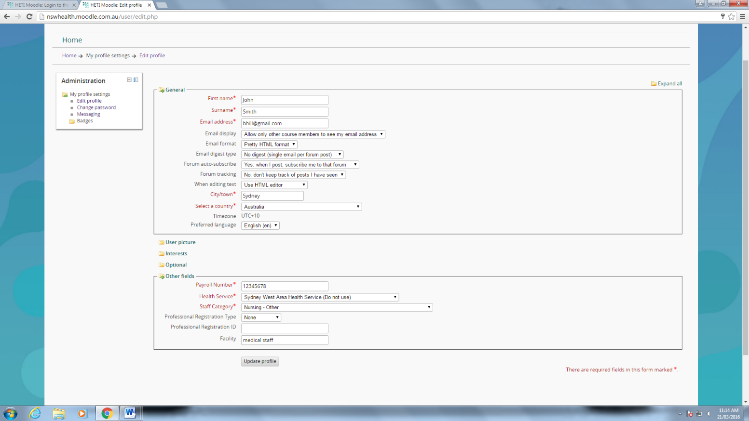

**Make up 8 digit number**

Select the Mandatory Training from the list.

**STEP 4: To commence your online training – Click on “OTHER” section **

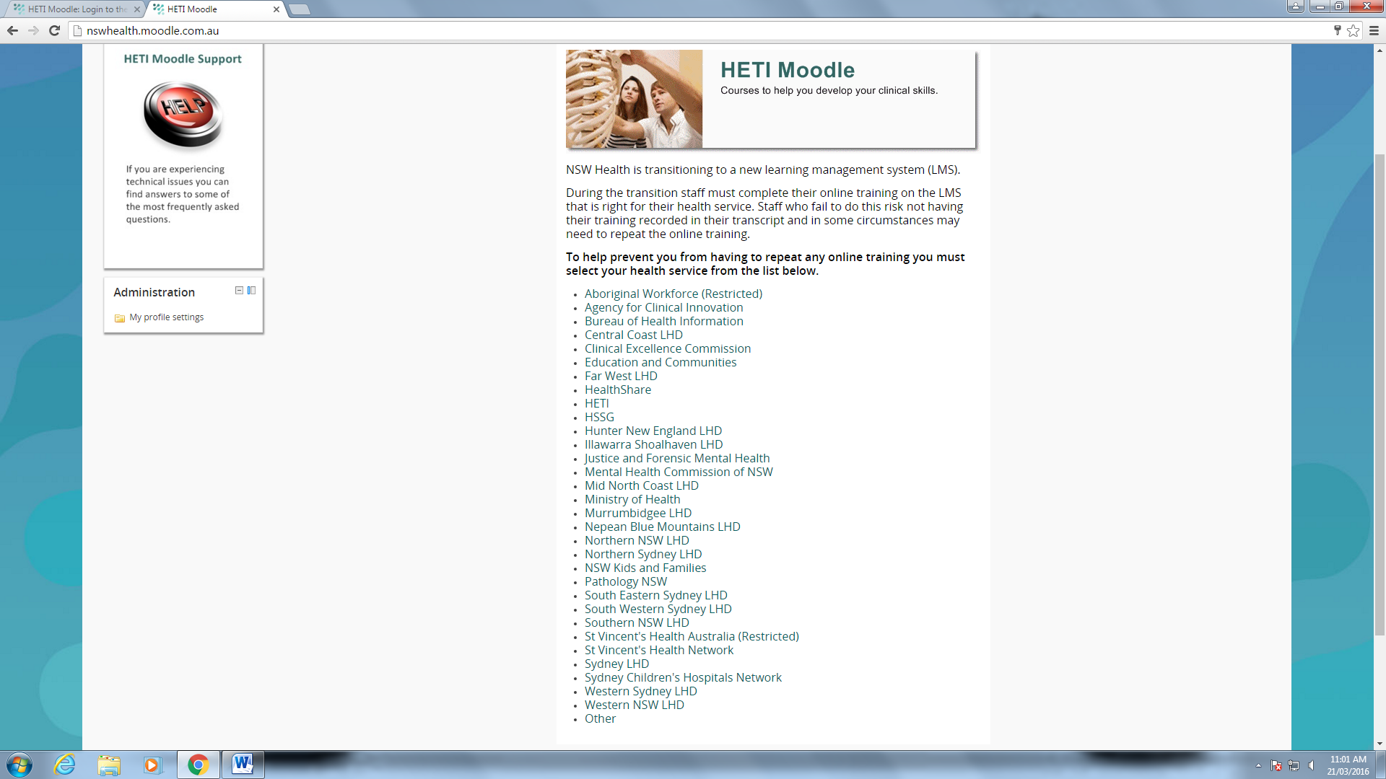

**Select “Other”**

**STEP 5: Click the box “LEARN”**

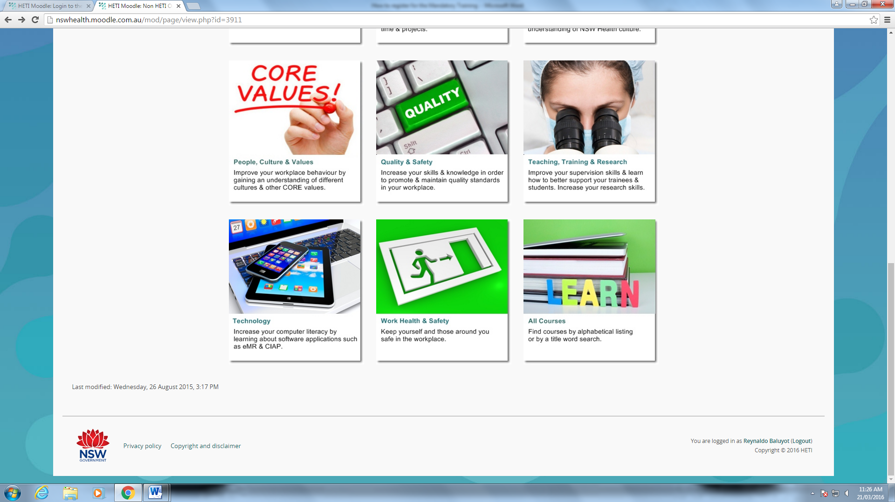

**Click on Box “Learn”**

Select the Mandatory Training from the list.

**Courses are listed in alphabetical order according to the first word in their title. For example if a title begins with "The" it will be listed under "T".**

**If you cannot find the course you are looking for, you can use the course search box in the top right hand corner of this page.**

**STEP 6a: Select the following courses from the list below **

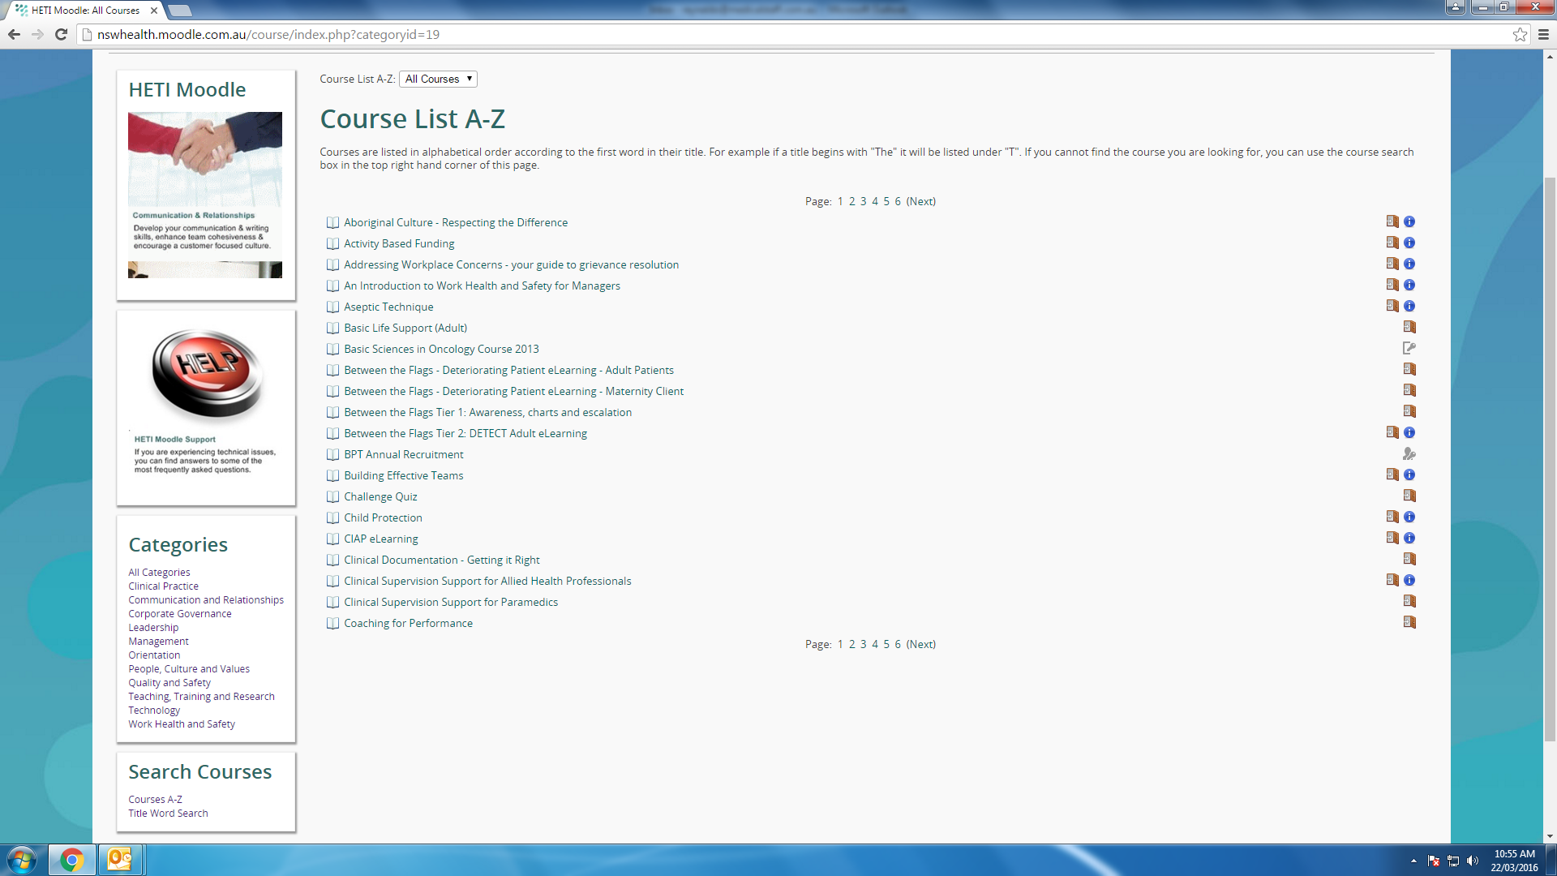

Select the Mandatory Training from the list.

**Select the following**

**1) Adult Basic Life Support**

**2) Aseptic Technique**

**3) DETECT - Between the Flags Deteriorating Patient e-learning: Adult Patients**

Select the Mandatory Training from the list.

Select the Mandatory Training from the list.

**STEP 6b: Select the following courses from the list below. **

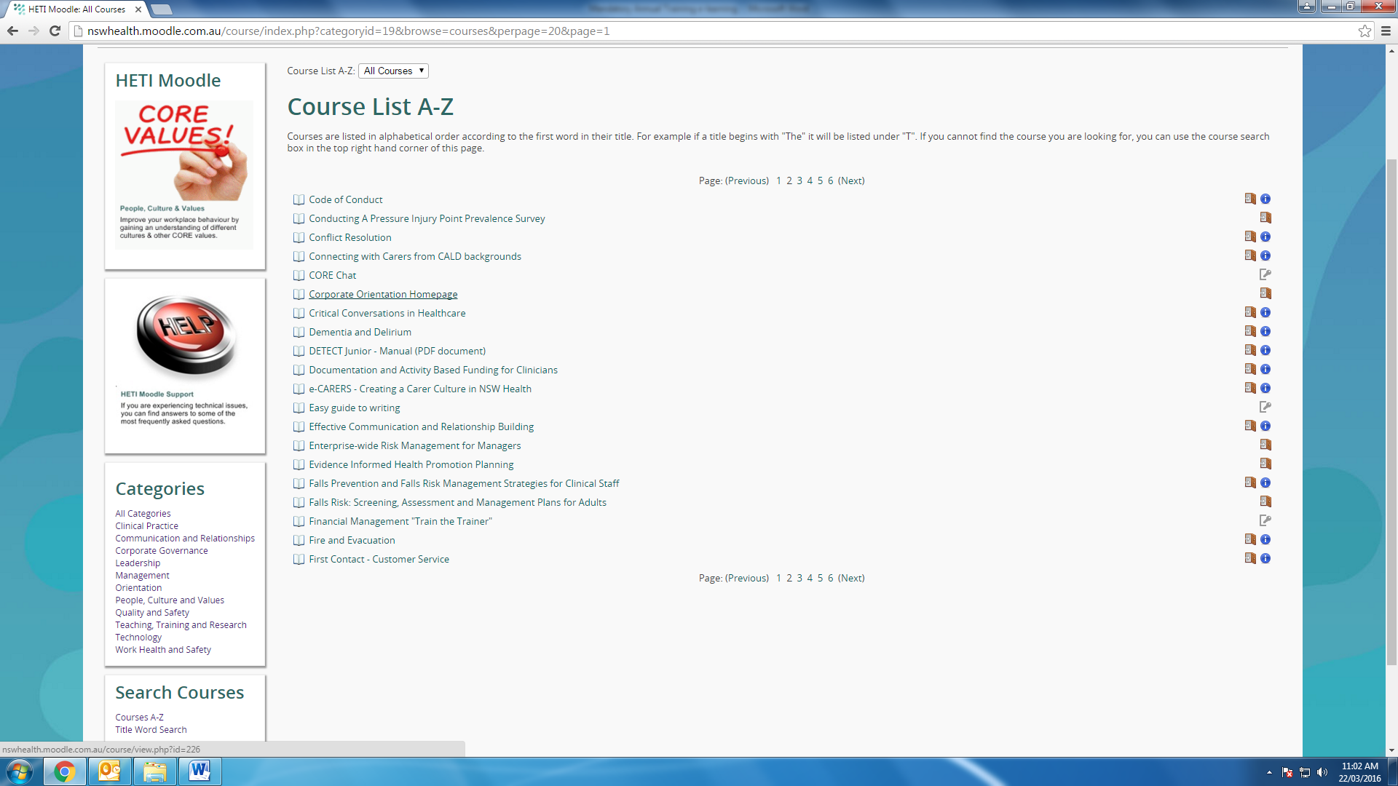

**Select**

**4) Fire and Evacuation**

Select the Mandatory Training from the list.

**STEP 6c: Select the following courses from the list below **

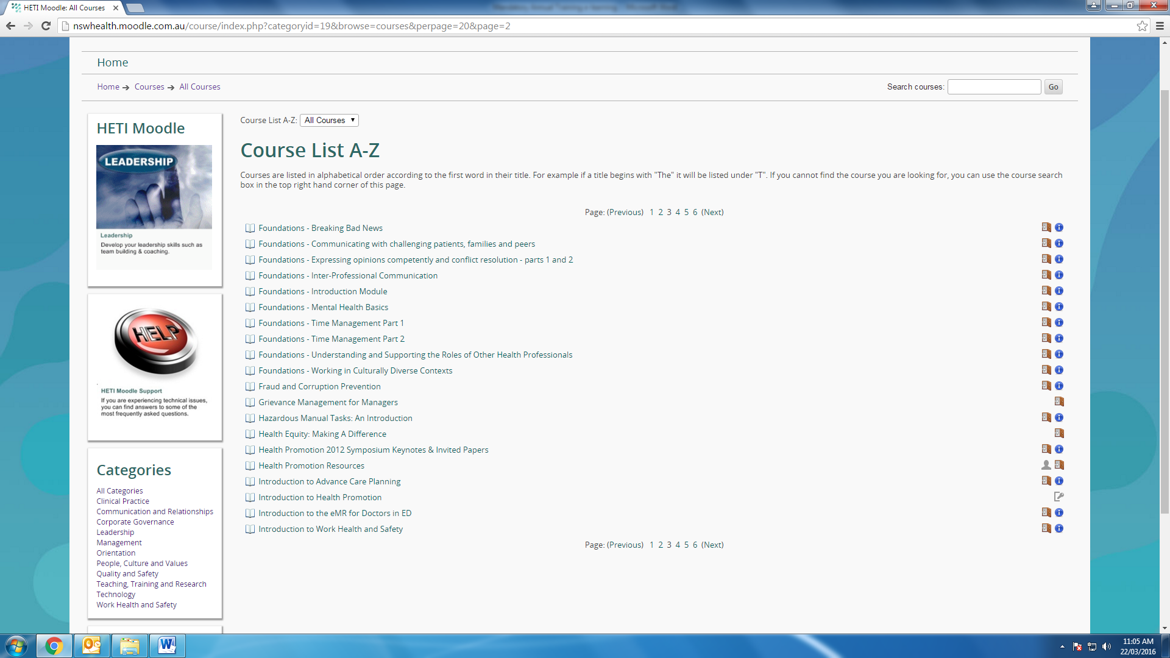

Select the Mandatory Training from the list.

**Select**

**5) Hazardous Manual Task**

**6) Introduction to Work Health and safety**

Select the Mandatory Training from the list.

**Select the course of interest by clicking on the title: **

|  |  |
| --- | --- |
| [**http://elderabuseprevention.e3learning.com.au**](http://elderabuseprevention.e3learning.com.au/)  This course is targeted at anyone working with older people.  The course will take 1.5 to 2 hours to complete and is free of charge.  It includes a range of case studies, some in video format to illustrate these concepts and there is a short assessment at the end. Participants are required to register for the course and will be issued with a certificate upon successful completion of the course and assessment. | [**https://learn.bloodsafelearning.org.au**](https://learn.bloodsafelearning.org.au)  If you are new to BloodSafe eLearning Australia and haven’t completed any courses before, you will need to register. Registration collects some details about you including your workplace (if employed or a student), work area, profession and email address.  Ensure accuracy when entering these details as they are used to verify your record, send course certificates to you (via email), and for organisation reporting on course completions.  To register, select the red New Registration button on the homepage, or in the top right menu bar of any website page. The sites Terms of Use will display, then after accepting that, the registration form needs to be completed, and select ‘Submit to create new account’. |
| [**http://www.dementiadynamics.com.au/**](http://www.dementiadynamics.com.au/)  The Dementia Dynamics Toolkit is a resource for addressing responsive behaviours that is being provided to all Australian residential aged care facilities in 2014.  Explore the current evidence-based information about dementia and responsive behaviours and, if you work in residential aged care in Australia, you can [register and login](http://www.dementiadynamics.com.au/members) to access a range of information and support that will help aged care staff get the most out of the toolkit. | [**https://alison.com/courses/Mental-Health**](https://alison.com/courses/Mental-Health)  Interested in learning more about the workings of the human mind? Consider ALISON's free, mental health courses online which dig into topics such as mental health and illness, understanding behaviours, burnout and depression and more. |
| **Other available HETI Moodle courses that you might be interested in:**  **Please select from A-Z list from (Page 5, 6, 7)**  Example:   * Introduction Advance Care Planning * Clinical Documentation – Getting it Right * CIAP Learning | **Please note:**  **Once you have completed the course you can then generate and print your certificate.**  **Copy of certificates to be sent to : compliance officer via** [**maria@medicalstaff.com.au**](mailto:maria@medicalstaff.com.au) |